Design Principles - Single Responsibility Principle (SRP)
# Source: AI Source: Provided by: [Data Path: Persons Table -> ID Column: 1, Name_En Column: Motasem Essam] -> From: [ChatGPT] on [1/23/2026]
The Single Responsibility Principle states that a class should have only one reason to change. Each class should focus on one responsibility or functionality.
👉 Think of it like a specialist worker: each person does one job really well rather than juggling multiple unrelated tasks.

🔑 Key Points
# Source: AI Source: Provided by: [Data Path: Persons Table -> ID Column: 1, Name_En Column: Motasem Essam] -> From: [ChatGPT] on [1/23/2026]
• Each class should have only one responsibility
• Changes to one responsibility should not affect other responsibilities
• Promotes high cohesion and low coupling
• Makes code easier to maintain, extend, and test

❌ Bad Example
# Source: AI Source: Provided by: [Data Path: Persons Table -> ID Column: 1, Name_En Column: Motasem Essam] -> From: [ChatGPT] on [1/23/2026]
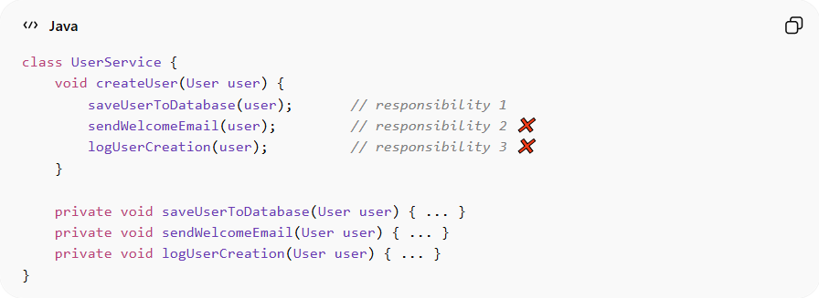
class UserService {
void createUser(User user) {
saveUserToDatabase(user); // responsibility 1
sendWelcomeEmail(user); // responsibility 2 ❌
logUserCreation(user); // responsibility 3 ❌
}

private void saveUserToDatabase(User user) { ... }
private void sendWelcomeEmail(User user) { ... }
private void logUserCreation(User user) { ... }
}
Problems:
• Class handles multiple responsibilities
• Changes to email logic or logging may affect user creation
• Hard to test, maintain, or extend

✅ Good Example
# Source: AI Source: Provided by: [Data Path: Persons Table -> ID Column: 1, Name_En Column: Motasem Essam] -> From: [ChatGPT] on [1/23/2026]
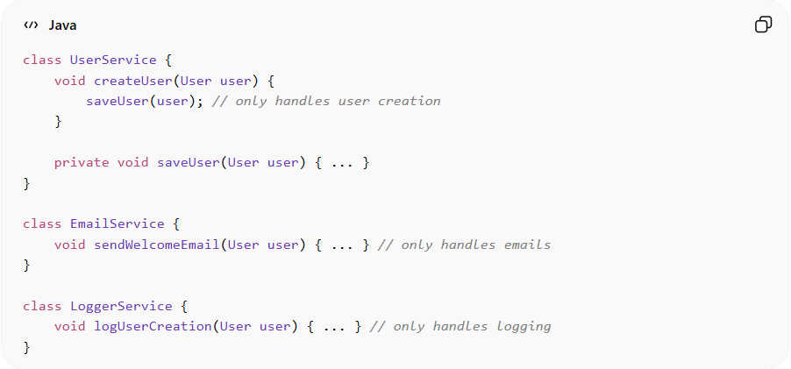
class UserService {
void createUser(User user) {
saveUser(user); // only handles user creation
}

private void saveUser(User user) { ... }
}

class EmailService {
void sendWelcomeEmail(User user) { ... } // only handles emails
}

class LoggerService {
void logUserCreation(User user) { ... } // only handles logging
}
Benefits:
• Each class has a clear, single responsibility
• Easier to test, maintain, and extend
• Changes in one responsibility don’t affect other modules
• Supports clean and modular architecture

⚡ When to Apply
# Source: AI Source: Provided by: [Data Path: Persons Table -> ID Column: 1, Name_En Column: Motasem Essam] -> From: [ChatGPT] on [1/23/2026]
• Always — particularly in object-oriented and enterprise systems
• Useful when responsibilities may change independently
• Works best with high cohesion and modular design
• Combine with DRY and KISS for maintainable, readable code

